

Module (CSS and CSS 3) -2

1. What are the benefits of using CSS?

CSS is a design language that makes the web page attractive and beautiful. With CSS, customization of a web page becomes easy. It is also simple to accomplish the completion of a greater amount of styling with minimal effort.

There are various advantages of CSS. It is majorly responsible for rendering color, font size, font style, and much more. It works by providing various style options to the HTML elements.

1. **Consistency & Maintenance**:

Since CSS is consistent, the developer does not have too put in a lot of effort. The formatting can be changed easily and the changes made get reflected to the web pages using that style sheet.

Css is also very easy to maintain. To change the style of a single element, very little editing is required. Also, the changes are reflected throughout wherever that particular styling is used.

1. **Flexibility:**

A greater flexibility can be achieved using CSS. It is compatible with both big and small screens. A responsive design can be created using CSS which is the best fit for all types of screens.

1. **Page Load Efficiency**

When the increase in the size of the code, the loading speed of the page decreases. CSS enables style the elements using less code. It increase the page load efficiency. To style multiple elements with a similar style, we can apply that style to a group of elements.

1. **Enhanced Design Options**

CSS can style the web pages with variety of styles. While using only HTML, a plain and basic web page can be created. A visually appealing web page can be created using CSS. This results in an increased engagement on the page.

1. **Platform Independence**

CSS is platform-independent as it provides features like MEDIA QUERIES and RESPONSIVE DESIGN that can enabe the developer to write code to run on various devices. therefore, there is no need to write an entirely separate style sheet for each individual platform of device.

1. **Animations and Effects**

CSS allows for animations and transitions, enhancing the user experience. Interactive elements can be created with CSS without relying on JavaScript or other scripting languages.

1. **SEO-Friendly**

Clean and structured CSS code can enhance website’s search engine optimization and potentially boost site’s search rankings, leading to increased visibility and traffic.

1. What are the disadvantages of CSS?
2. **Cross-Browser Issues:**

This is on of the major problem in CSS, Different browsers works differently with CSS. So the changes implemented in website via CSS codes are reflected properly among all browsers

1. **Complex Layouts:**

If there is a complex layout, it might be difficult to creat the same using CSS. There can be several problems occurred due to the positions and responsiveness.

1. **Over Specificity:**

Over Specificity is an issue in CSS where the selectors are defined as having lot of levels. In the case of nested selectors or over-specified selectors, the code is not quite readable and it is difficult to make changes.

1. **File Size:**

If the web page and its styling are very large, it can hamper the performance of the website. A large sized file can degrade the loading time of website.

1. What is the difference between CSS2 and CSS3?

CSS2 and CSS3 are two major versions of the CSS specification, each bringing its own set of enhancements. Here are the key differences between CSS2 AND CSS3

1. **CSS2:** was released in 1998 with added styles for other media types so that it can be used for page layout designing.

***CSS3:*** was released in 1999 and presentation-style properties were added in it that allows to build a presentation from documents.

1. **CSS2:** was comprised of a single document.

***CSS3:*** has its specifications divided into many individual modules, which makes CSS3 a whole lot easier to handle.

1. **CSS2:** designers could only use “web-safe fonts” for being 100% sure to use fonts that would always display the same on every machine.

***CSS3:*** the designers can now use special fonts, like those available in Google Fonts and Typecast.

1. **CSS2:** Introduced a basic set of selectors, including element selectors, class selectors, and ID selectors.

***CSS3:*** Expanded the selector capabilities with advanced selectors such as attribute selectors, pseudo-classes and pseudo-elements. This enhances the ability to target and style specific elements.

1. **CSS2:** had no rounded borders.

***CSS3:*** has rounded borders that help in rounding up the borders without any hassle.

1. **CSS2:** developers had difficulty because the standard was not equipped with automatically breaking the text so that fits within a box.

***CSS3:*** has capability to split text sections into multiple columns so that it can be read like a newspaper.

1. **CSS2:** did not include media queries, which are essential for responsive web designs.

***CSS3:*** Introduces media queries, allowing styles to be applied based on characteristics of the devices, such as screen size, resolution, or orientation. This is crucial for creating responsive and adaptive designs.

1. **CSS2:** did not have dedicated features for flexible box layouts or grid layouts.

***CSS3:*** Introduces Flexbox and Grid Layout modules, offering powerful tools for creating complex and responsive layouts. Flexbox is designed for one-dimensional layouts, while Grid Layout is designed for two-dimensional Layouts.

1. **CSS2:** did not include built-in support for transitions and animations.

***CSS3:*** Introduces the transition property for smooth transitions between states and the @keyframes rules for defining animations.

1. **CSS2:** had basic typography features, such as font-family, font-size, and text-align.

***CSS3:*** Expands typography options with features like @font-face (for custom fonts), text-shadows, word-wrap, and hyphens, providing moe control over text rendering.

1. Name a few CSS style components

A CSS style consists of several components that define how an HTML element should be visually presented on a web page. These components work together to create the desired appearance of web content. The main components of a CSS style include:

1. **Selectors:** Selectors are used to target specific HTML elements to which the style will be applied. CSS selectors can target elements by their HTML tag name (element selectors), class names (class selectors), IDs (ID selectors), attributes, and more.

Example selectors:

Element selector : p {...}

Class selector : .my-class {...}

ID selector : #my-id {...}

2. **Properties:** Properties are the individual style attributes that you want to set for the selected elements. Each property corresponds to a specific aspect of an element's appearance, such as color, font size, margin, padding, or border.

Example properties:

Color : Sets the text color.

font-size : Defines the font size.

margin : Specifies the margin around an element.

Padding : Sets the padding inside an element.

border : Controls the border of an element.

3.**Values:** Values are the settings or values you assign to CSS properties. Values can be specific (e.g., `12px`, `red`), relative (e.g., `em`, `%`), or keyword-based (e.g., `bold`, `left`).

Example values:

12px : A specific pixel size.

Red : A specific color.

1em : Relative size based on the element's font size.

left : A keyword value indicating alignment.

4. **Declaration Block:** A declaration block is a set of one or more property-value pairs enclosed within curly braces `{}`. Each property-value pair is separated by a semicolon `;`.

5. **Rule Set:** A rule set is a complete CSS rule that consists of a selector and its associated declaration block. It defines which HTML elements should be styled and how they should be styled.

1. What do you understand by CSS opacity?

The CSS opacity property allows to specify how specific page ELEMENTS will be blend, providing style and emphasis to critical page parts.

This feature enables to change the number of DIFFUSED VIRTUAL LIGHT that appears to pass through a paragraph,image,or other page elements.

There are ways to modify the opacity of elements when formatting HTML and CSS and multiple reasons to use this effect in a design.

Opacity can also be used to soften a shadow, fade stuff in and out of view. These effects can be achieved using the OPACITY PROPERTY

The transparent color name, or alpha channels, which are a color value extension with an additional segment for regulating opacity.

1. How can the background color of an element be changed?

With the help of **background-color property** in css the background color of an element can be change.

It can set background color bye selecting the element by its class name of id name and then apply the background-color property on it to set the background color.

Syntax: background-color: colorname;

Example:

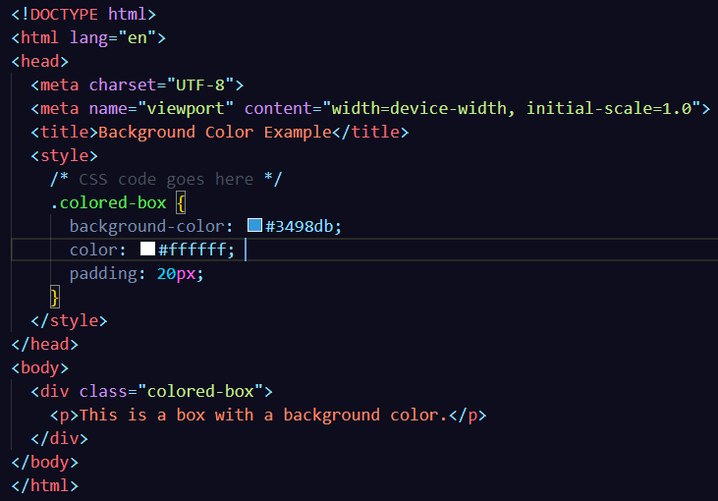

1. How can image repetition of the backup be controlled?

With the help of **background-repeat property** in css image repetition of the backup be controlled in both horizontally and vertically. It also decides whether the background image will be repeated or not.

Syntax: background-repeat: repeat; or

repeat-x; or

repeat-y; or

no-repeat; or

initial; or

inherit;

1. What is the use of the background-position property?

The background-position property in CSS is mainly used to sets the initial position for the background image.

It is used to set an image at a certain position.

Syntax: background-position: value;

By default, the background-image is placed to the top-left corner of an element with a repetition on both horizontally & vertically

1. Background-position: left top; it is used to set the image at the left top
2. Background-position: left center; it is used to set the image at the left center
3. Background-position: left bottom; it is used to set the image at the left bottom
4. Background-position: center top; it is used to set the image at the center top
5. Background-position: center bottom; it is used to set the image at the center bottom
6. Background-position: right top; it is used to set the image at the right top
7. Background-position: right center; it is used to set the image at the right center
8. Background-position: right bottom; it is used to set the image at the right bottom
9. Which property controls the image scroll in the background?

The background-attachment property is used to specify that the background image is fixed or scroll with the rest of the page in the browser window.

The property has three values (1) scroll (2) fixed (3). Its default value is scroll.

1. Why should background and color be used as separate properties?

Using background and color as separate properties in CSS allows for greater flexibility and control over the styling of elements. While the background shorthand property combines various background related properties into a single declaration separating background and color provides the following advantages

1. **Modularity and Readability:**

Separating background and color into distinct properties make the code more modular and easier to read. Each property is responsible for a specific aspect of styling, making it clearer for developers to understand and maintain.

1. **Fine-Tuned Control:**

Separating background and color allows for more granular control over each aspect.

1. **Override and inheritance:**

When properties are separated, it becomes easier to override or inherit specific styles. This is especially useful when dealing with complex stylesheets or when applying styles to specific elements.

1. **Compatibility and browser support:**

In some cases, using shorthand properties like background may not be supported consistently across all browsers, especially when dealing with newer CSS feature.

1. **Ease of Maintenance:**

Having separate properties makes it more straightforward to locate and modify the relevant styles. Its important in larger projects.

1. How to center block elements using CSS1?

Centering block-level elements in CSS1 typically involved using a combination of properties like text-align and setting margins.

1. Horizontal Centering: set left and right margins to auto for a block-level element. This works for horizontally centering the element within its containing block.

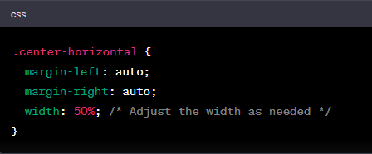

1. Vertically Centering:

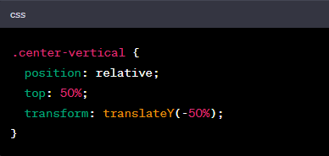

1. How to maintain the CSS specifications?

Maintaining CSS specifications involves several best practices and strategies to ensure consistency, scalability, and ease of maintenance.

1. **Documentation:**

Document CSS code thoroughly. Using comments to explain complex styles, the purpose of specific rules, and any dependencies.

1. **Modularization:**

Break down CSS into modular components. Each component should be responsible for styling a specific part of application or webpage.

1. **Version Control:**

Use version control systems (Git etc) to track changes to CSS files. This allows to roll back changes, collaborate with others, and maintain a history of styles.

1. **Testing:**

Regularly testing style across different browser to catch any inconsistencies or issues.

1. **Responsive Design:**

Design and test for responsiveness. Using media queries and other responsive design techniques to ensure styles adapt well to various screen sizes and devices.

1. What are the ways to integrate CSS as a web page?

There are several ways to integrate CSS into a web page. The choice of method often depends on factors such as the project’s requirement, development preferences, and the level of control needed over styling.

1. **Inline Style:**

Inline styles involve applying styles directly within HTML elements using the style attribute. This method is suitable for individual elements.

1. **Internal Styles:**

Internal styles involve placing CSS rules within a <style> element in the <head> section of HTML document. This method is useful for applying styles to multiple elements within same document.

1. **External Styles:**

External styles involves creating a separate CSS file and linking it to the HTML document. This method is beneficial for maintaining a consistent style across multiple pages.

1. What is embedded style sheets?

Embedded styles also known as internal or inline styles, refer to the practice of including CSS rules directly within HTML document.

The styles are defined within a <style> element, which is placed in the <head> section of the HTML document.

1. What are the external style sheets?

External style sheets are separate CSS files that contain style rules and are linked to HTML documents.

These external style sheets provide a way to centralize and resuse styles across multiple pages within a website.

By using external style sheets, We can maintain a consistent design, update styles in one place, and improve the overall organization of project.

1. What are the advantages and disadvantages of using external style sheets?

Using external style sheets offers several advantages, and disadvantegs.

**Advantages**

1. *Modularity*

External style sheets promote modularity by separating the HTML from the presentation. This separation enhances code organization and maintainability.

1. *Consistency:*

Styles defined in an external style sheet can be reused across multiple HTML pages, ensuring a consistent look and feel throughout a website.

1. *Ease of Maintenance:*

Updates or changes to the styling can be made easy in a single external CSS file. This centralized approach simplifies maintenance, reduces redundancy, and ensure changes apply to all linked HTML pages.

1. *Efficiency:*

External style sheets can be cached by browsers. Once a user visit a page on a website, subsequent visit to other pages using the same style sheet can benefit from cached resources, resulting in faster page loading times.

**Disadvantages**

1. *Additional HTTP Request:*

Each external style sheet requires an additional HTTP request, which can impact page loading times, especially on slower networks. However, this impact is often mitigated by browser caching

1. *Rendering Delay:*

The browser might delay rendering the page until the external style sheet is loaded, leading to a potential delay in the initial display of the page.

1. *Dependence on File Availability:*

If the external style sheet fails to load, the associated HTML page may lack proper styling, leading to a less than optimal user experience.

1. *Limited Local Modifications:*

External Style sheets are shared across multiple HTML pages. While this promotes consistency, it can limit the ability to make local modification specific to one page without creating additional styles.

1. What is the meaning of the CSS selector?

In CSS, a Selector is a pattern or a set of rules that define which element in an HTML document will be targeted and styled. Selectors are a crucial part of CSS as they allows to apply styles to specific elements or groups of elements on a webpage.

1. Element Selector: selects all instances of a specific HTML element.



1. Class Selectors: selects elements with a specific class attribute. We can add class selectors by .(classname)

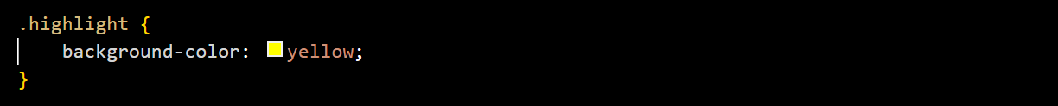

1. ID Selector: selects a single element with a specific ID attribute. We can add id selector by using #(id name)

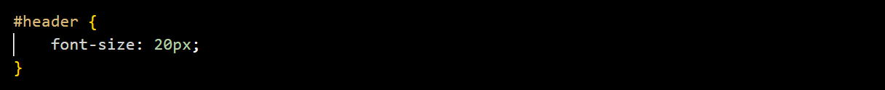

1. Attribute Selector: selects elements based on the presence or value of their attributes.

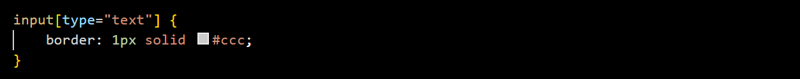

1. Descendant Selector: selects an element that is a descendant of another specific element.

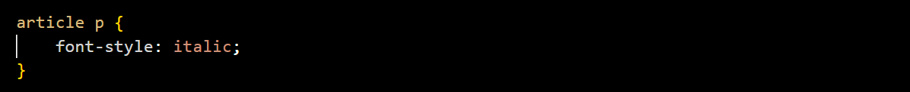

1. Child selector: selects an element that is a direct child of another speficic element.



1. Group Selector: selects all the elements with the same style definitions. It is used to minimize the code.

h1, h2, p {

text-align: center;

color: blue;

}

1. What are the media types allowed by CSS?

Media types in CSS are used to specify the target devices or media on which a document is being displayed. It allows to apply different styles based on characteristics such as screen size, device capabilities, or the type of output device.

1. All

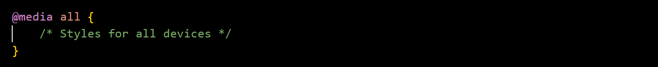

1. Screen

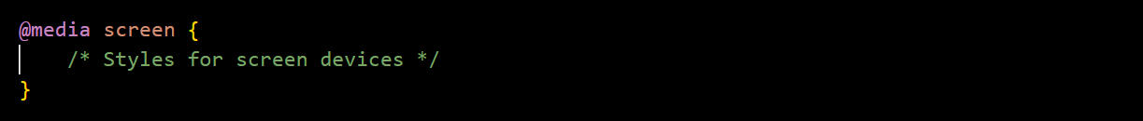

1. Print

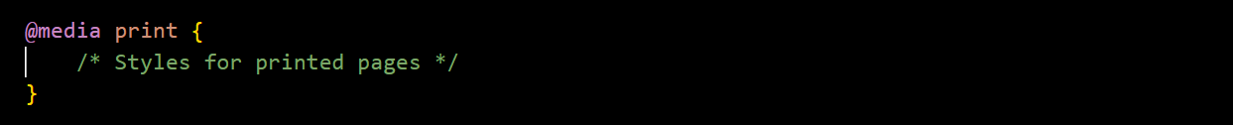

1. Speech:

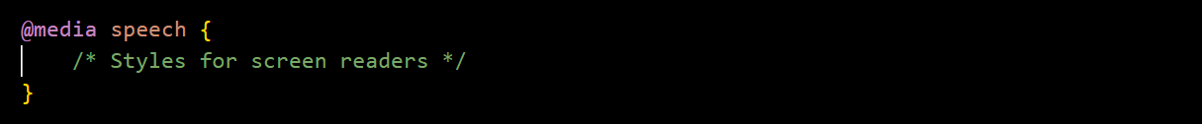

1. Braille

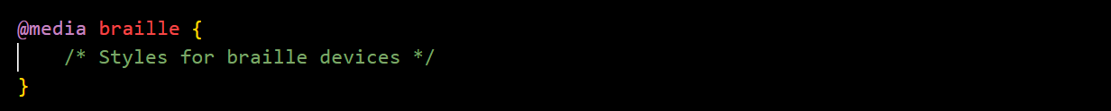

1. Aural:



These media types can be combined or used individually to create responsive and device-specific styles.

1. What is the rule set?

In Css a rule set consists of selector and declaration block. The selector defines which HTML elements the styles should apply to, and the declaration block contains one or more declarations that specify the styles for the selected elements.

Example :

Selector {

property: value;

}

Selectors identifies the HTML elements to which the style to apply

Declararation block encloses in curly braces{}, contains one or more property value

pairs separated by semicolons. Each property-value pairs defines a specific style rule.

1. 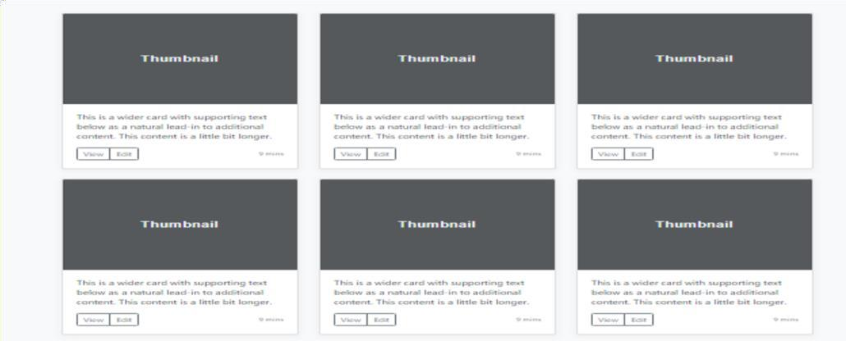Create Layouts :

I have created Layout in separate file, and uploaded in GitHub. Here below is Screen Shot of the same.

